ID :

**MOHAMED JABIR**

PROJECT REPORT

|  |
| --- |
|  |
| BLOOD BANK MANAGEMENT SYSTEM |
|  |
| BY |
|  |

**ABSTRACT**

This is my **“Blood Bank Management System”** project where a user can find all blood group types if any need, they can donate blood, they can get blood from someone through this website. This report outlines the project's objectives, key features, technologies used, implementation details, challenges faced, and future enhancements.

**TABLE OF CONTENT**

1. INTRODUCTION
2. Project Overview
3. Technologies Used
4. Implementation Details
5. Conclusion
6. References

**1.INTRODUCTION**

This is my **“Blood Bank Management System”** project where a user can

find all blood group types if any need, they can donate blood, they can

get blood from someone through this website.

**2.PROJECT OVERVIEW**

The project integrates Django framework along with Bootstrap and CSS for frontend styling and responsiveness. The website shows available blood group data to the user so that the user can apply for blood if they in need or they can donate their blood so people who are in need.

**3.TECHNOLOGIES USED**

* Django
* Python
* SQLite3 (default database engine)
* H.T.M.L
* C.S.S
* Bootstrap

**Django**: Django is a high-level Python web framework that facilitates rapid development of secure and maintainable websites and web applications. It follows the model-view-template (MVT) architectural pattern.

**Python**: Python was created by Guido Van Rossum and was first released in 1991, It has gained immense popularity due to its simplicity, readability, and versatility.

Python is a **popular programming language** that has found its way into various domains.

**SQLite3:** SQLite is a lightweight, self-contained SQL database engine used as the default database engine in Django projects. It's suitable for small to medium-sized web applications or prototypes.

**HTML:** HTML (Hypertext Markup Language) is the standard markup language used to create the structure and content of web pages. It defines the elements and tags used to display text, images, links, and other multimedia content on the web.

**CSS:** CSS (Cascading Style Sheets) is a stylesheet language used to style the presentation and layout of HTML documents. It defines the styles, such as colors, fonts, margins, and padding, to enhance the visual appearance of web pages.

**Bootstrap 4:** Bootstrap is a popular front-end framework for building responsive and mobile-first web projects. It provides pre-designed templates and components using HTML, CSS, and JavaScript for creating user interfaces.

**4.IMPLEMENTATION DETAILS**

* HOME PAGE
* BLOOD AVAILABILITY
* BLOOD DONOR
* NEED BLOOD

**HOME PAGE:**

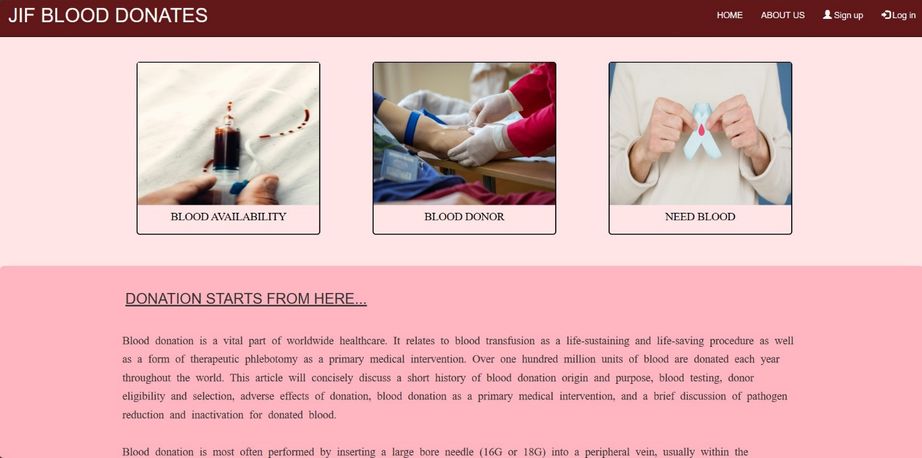

technologies used in home page:

**views.py**

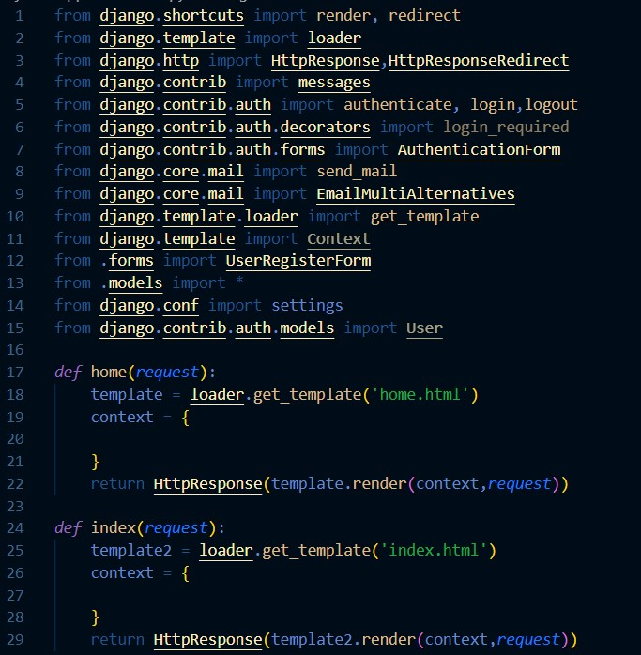

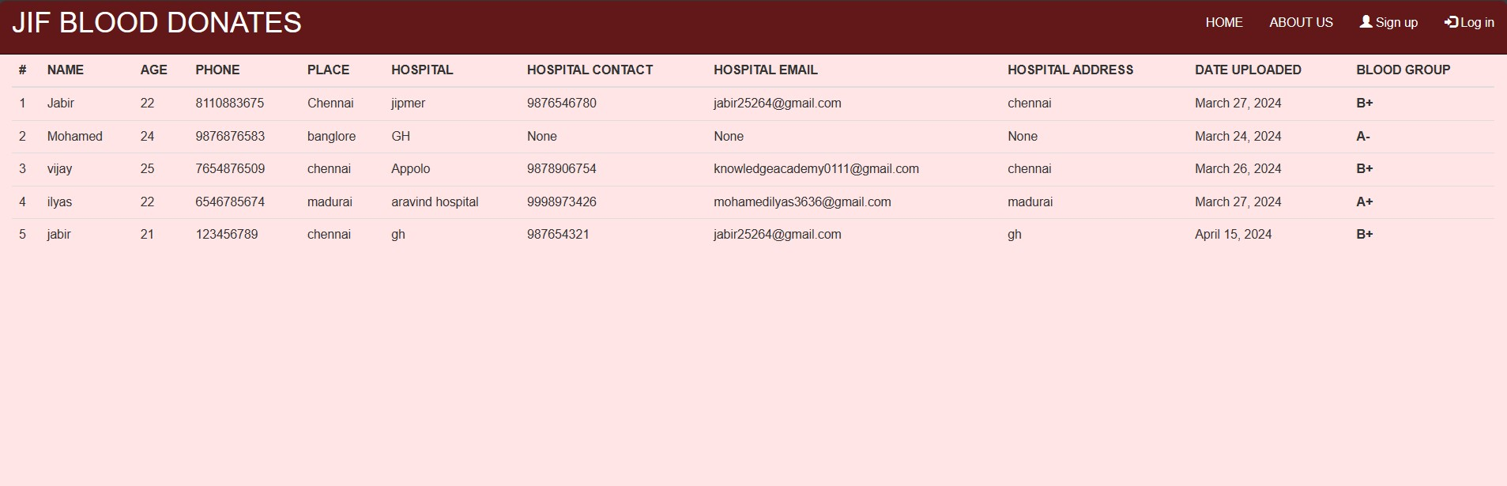**BLOOD AVAILABILITY:**

technologies used in BLOOD AVAILABILITY:

**views.py**

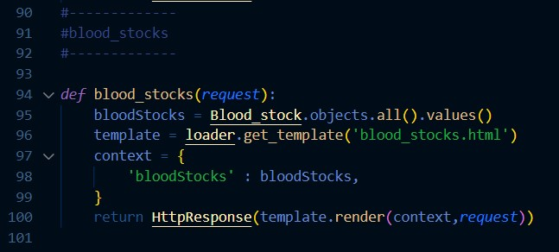

**models.py**

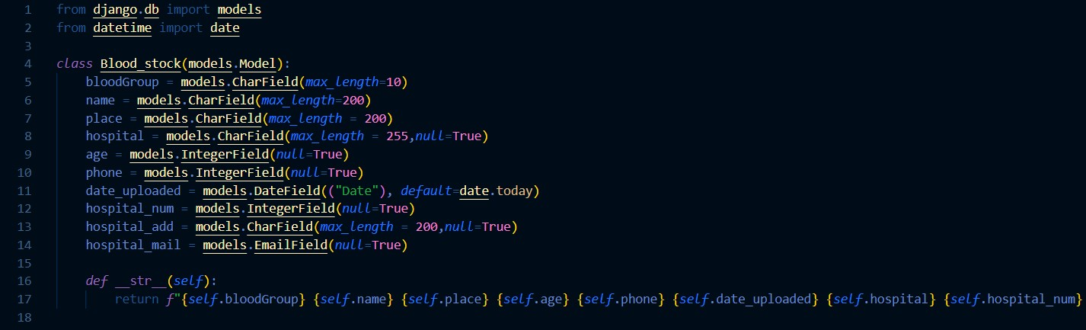

**BLOOD DONOR:**

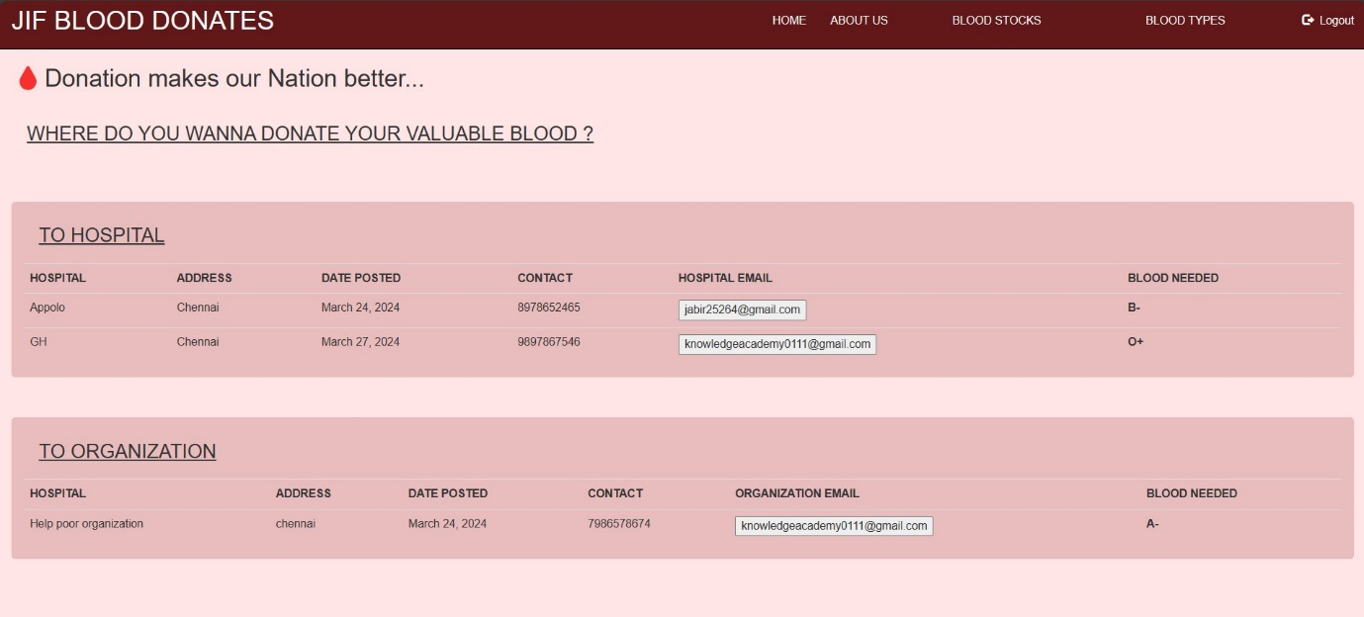

technologies used in BLOOD DONOR:

**views.py**

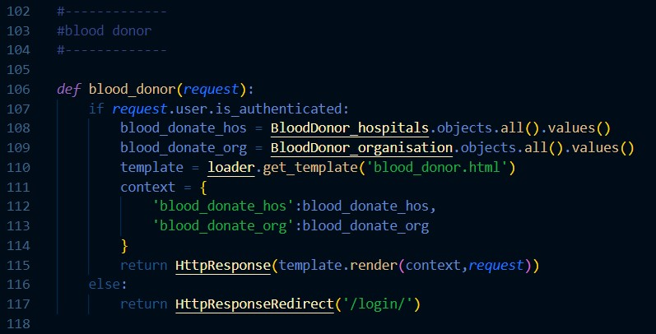

**models.py**

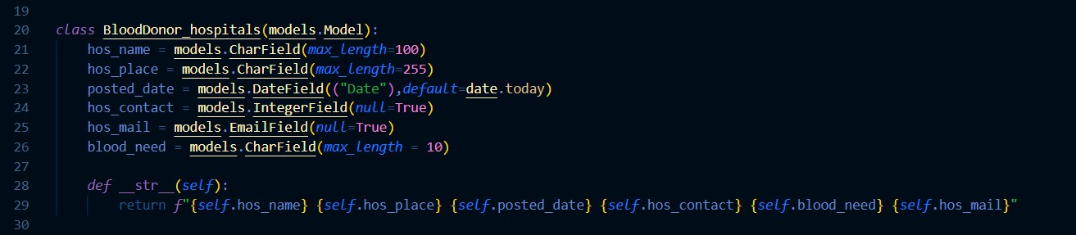

**NEED BLOOD:**

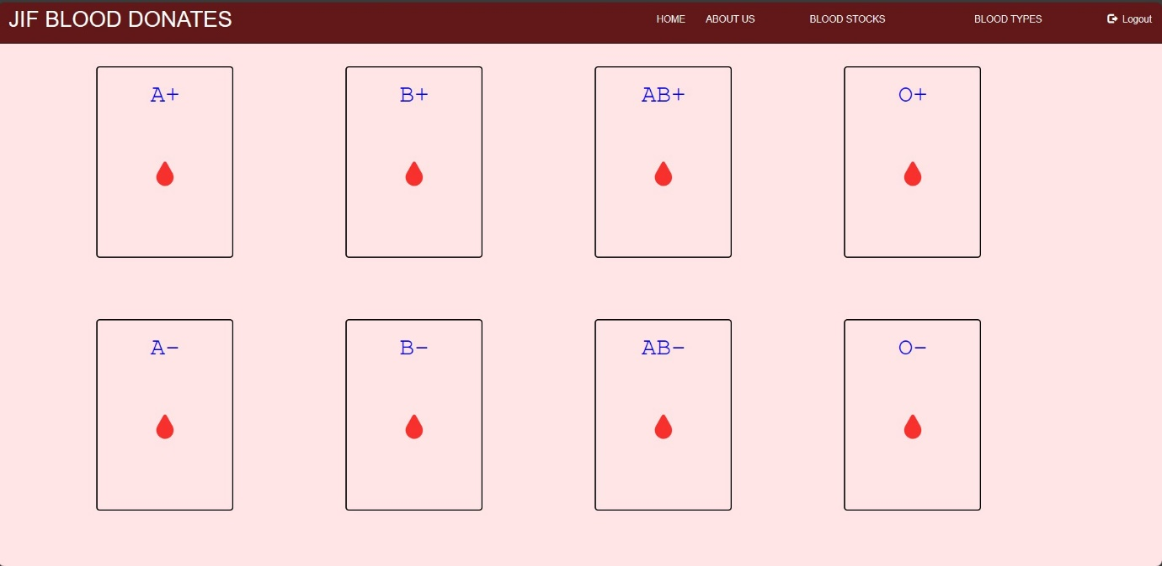

technologies used in need BLOOD:

**views.py**

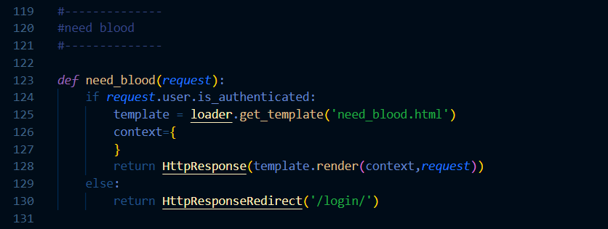

**5.CONCLUSION**

The **Blood bank management system** project successfully delivers a user-friendly and informative website using Django framework. Its modular design, integration of various technologies, and focus on user experience make it a valuable tool for blood donating.

**6.REPORT**

1. DJANGO - [**Django documentation | Django documentation | Django (djangoproject.com)**](https://docs.djangoproject.com/en/5.0/)
2. BOOTSTRAP - [**Bootstrap · The most popular HTML, CSS, and JS library in the world. (getbootstrap.com)**](https://getbootstrap.com/)